* Corresponding author E-mail address:

Received: 15 June 201X / Accepted: 20 October 201X / Published online: 4 November 201X

**Highlights**

* Between three to five highlights on major research findings should be supplied.
* Each highlight must not exceed 85 characters including space.
* Highlights should be provided separately and not appended with text of manuscript.

________________________________________________________________________________________

**Abstract**

Abstract must not (i) exceed 300 words; (ii) refer to table or figure; (iii) use acronym unless prior description has been provided; (iv) include reference. Abstracts must contain all information, including research questions / objectives of the study, methods, results and discussion, and conclusions.

1. **Introduction**

paragraphs continue from here and are only separated by headings, subheadings, images and formulae. The section headings are arranged by numbers, bold and 10 pt. The introduction should briefly describe: (i) the background of the study; (ii) research questions / gaps of research; (iii) research objectives / hypotheses. Use of diagrams and tables is not encouraged.

* 1. Structure

For this journal the files must be in MS Word format only and should be prepared with as minimal formatting as possible. Figures and tables should be supplied separately. Special fonts, such as fonts used in the Far East (Japanese, Chinese, Korean, etc.) may cause problems during processing. To avoid unnecessary errors, you are strongly advised to use the ‘spellchecker’ function of MS Word. Follow this order when typing manuscripts: Title, Authors, Affiliations, Abstract, Keywords, Main text (including figures and tables), Acknowledgements, References, Appendix.

Specific keywords that are unique to the topic of research should be selected in order to improve visibility of the manuscript, not limited to single word, and are usually not present in the title of the manuscript. Maximum number of keywords is six. Collate acknowledgements in a separate section at the end of the article and do not include them on the title page, as a footnote to the title or otherwise.

Bulleted lists may be included and should look like this:

* First point
* Second point
* And so on

Ensure that you return to the ‘Els-body-text’ style, the style that you will mainly be using for large blocks of text, when you have completed your bulleted list.

Please do not alter the formatting and style layouts which have been set up in this template document. As indicated in the template, papers should be prepared in single column format suitable for direct printing onto A4 paper (192mm x 262 mm). Do not number pages on the front, as page numbers will be added separately for the preprints and the journal. Leave a line clear between paragraphs.

* 1. Construction of references

References should be added at the end of the paper, and its corresponding citation will be added in the order of their appearance in the text. Referencing style is APA. Other styles (example: Numbering) are allowed. The use of bibliographic software such as Endnote, Mendeley and RefWorks is strongly encouraged.

* 1. Section headings

Section headings should be left justified, with the first letter capitalized and numbered consecutively, starting with the Introduction. Sub-section headings should be in capital and lower-case italic letters, numbered 1.1, 1.2, etc., and left justified, with second and subsequent lines indented.

* 1. Footnotes

Footnotes should be avoided if possible. Necessary footnotes should be denoted in the text by consecutive superscript letters. The footnotes should be typed single spaced, and in smaller type size (8pt), at the foot of the page in which they are mentioned, and separated from the main text by a short line extending at the foot of the column. The ‘Els-footnote’ style is available in this template for the text of the footnote.

1. **Methods**
2. Structure

The research method should be detailed in terms of: (i) the design and quality control of the study (i.e., blank, positive / negative control, treatment, replicates); (ii) materials / samples / subjects and their characteristics (i.e., purity of materials, age of subjects, wet weight of animals); (iii) characterization / data collection / statistical analysis; (iv) approval from the Research Ethics Committee for research involving humans or animals.

Equations and formulae should be typed and numbered consecutively with Arabic numerals in parentheses on the right hand side of the page (if referred to explicitly in the text),

(1)



They should also be separated from the surrounding text by one space.

1. **Results and Discussion**
   1. *Tables and Figures*

Only numbers of tables (Example: Table 1) and figures (Figure 1) should be included to indicate the position on the text of the paper. All tables and figures must be provided separately from the manuscript. Captions must be typed above and below table and figure, respectively. Table must be formattable (i.e., not supplied as image). Resolution for figures must be at least 1200 (dpi). Table or figure from published materials allowed with the written permission of the corresponding publisher. All figures should be numbered with Arabic numerals (1,2,...n). Lettering and symbols should be clearly defined either in the caption or in a legend provided as part of the figure.

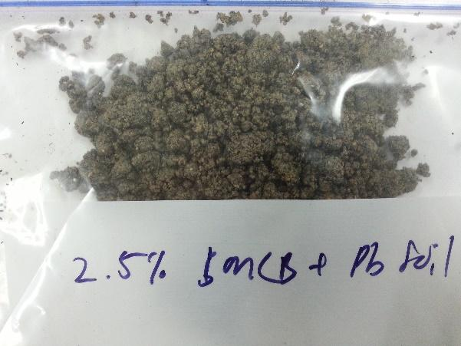 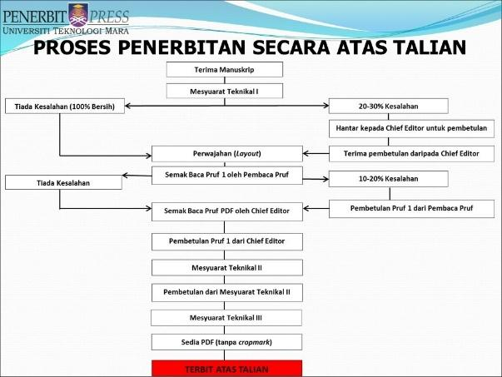

(a) (b)

Figure 1. (a) first picture; (b) second picture

All tables should be numbered with Arabic numerals. Headings should be placed above tables, left justified. Leave one line space between the heading and the table. Only horizontal lines should be used within a table, to distinguish the column headings from the body of the table, and immediately above and below the table. Tables must be embedded into the text and not supplied separately. Below is an example which authors may find useful.

Table 1. An example of a table

| An example of a column heading | Column A (t) | Column B (T) |
| --- | --- | --- |
| And an entry | 1 | 2 |
| And another entry | 3 | 4 |
| And another entry | 5 | 6 |

Table and figures should be systematically constructed to facilitate the discussion of results of the study. All tables and figures must be carefully described to answer the research questions. The results of the study need to be compared with the literature. All tables and figures must not be appended in the text of the manuscript.

1. **Conclusion**

**Acknowledgements**

The authors would like to extend my gratitude to the Faculty of Civil Engineering of Universiti Teknologi MARA for providing necessary facilities for this research. .

**References**

Clark, T., Woodley, R., De Halas, D., 1962. Gas-Graphite Systems, in “Nuclear Graphite” R. Nightingale, Editor. Academic Press, New York, p. 387.

Bernama.(2021, March 10). MPIC to focus more on pepper, cocoa, kenaf sectors in 2021.Retrieved from: http://www.theedgemarket.com.Accsessed on 15th April 2021.

Deal, B., Grove, A. (1965). General Relationship for the Thermal Oxidation of Silicon. *Journal of Applied Physics*, 36(1), 3770-3781. <https://dx.doi.org/10.54321>[/jap.v36i1.5426](https://dx.doi.org/10.24191/srj.v12i2.5426)

Deep-Burn Project: Annual Report for 2009, Idaho National Laboratory, Sept. 2009.

Fachinger, J., den Exter, M., Grambow, B., Holgerson, S., Landesmann, C., Titov, M., Podruhzina, T., 2004.“Behavior of spent HTR fuel elements in aquatic phases of repository host rock formations,” 2nd International Topical Meeting on High Temperature Reactor Technology. Beijing, China, paper #B08.

Fachinger, J. (2006). Behavior of HTR Fuel Elements in Aquatic Phases of Repository Host Rock Formations. *Nuclear Engineering & Design*, 236, 54-64. <https://dx.doi.org/10.12345>[/ned.v236i1.5426](https://dx.doi.org/10.24191/srj.v12i2.5426)

1. **An example appendix**

Authors including an appendix section should do so after References section. Multiple appendices should all have headings in the style used above. They will automatically be ordered A, B, C etc.

* 1. Example of a sub-heading within an appendix

There is also the option to include a subheading within the Appendix if you wish.